Name and Surname: Dmitriy Barabanov 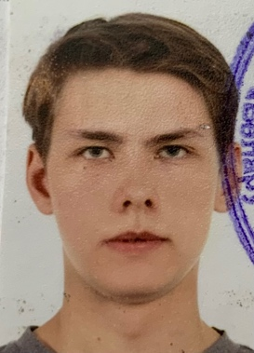

Phone: +375293191863

Marital Status: Single

Date of birth: 19.10.2003

Email: dmtrforwork@gmail.com

**About me**

I am a young hungry intelligent man who is searching for an exciting job in worldwide company. I’ve studied at best schools of Belarus, so I know how to get big amounts of information fast and do the best to reach my goals.

**Education**

High School: School №12 , Borisov, Belarus. 2010-2021.

Belarusian State Technological University, Faculty of Information Technology: 2021 – Present.

**Special skills**

C/C++/C# and JavaScript with React/HTML/CSS (Junior both), Pre-Intermediate English, Game Dev experience

**Hobbies**

Psychology, philosophy, music.

**Personal qualities**

Analytical and creative mindset, self-control, pro-active, motivated, investigative, fast teachable.

**Links**

Github: https://github.com/DMITRIYBY

CodeWars: https://www.codewars.com/users/DMITRIYBY